Encrypting an existing file with content:

Ansible-vault encrypt aws_creds

Create encrypting a file on-demand :

#This will create a file which is empty and we need to provide creds.

ansible-vault create aws_creds

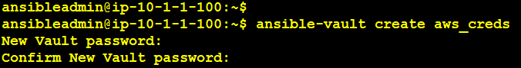

cat aws_creds

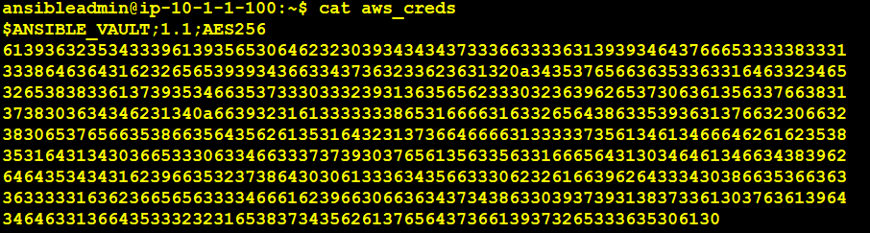

Decrypting the file :

ansible-vault decrypt aws_creds

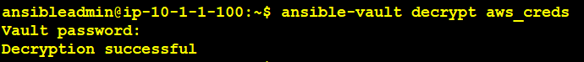

cat aws_creds



Encrypt a string :

ansible-vault encrypt_string 'India@123456' --name 'user_password'

Once provided the vault password, copy the encrypted data which is shown below screenshot.

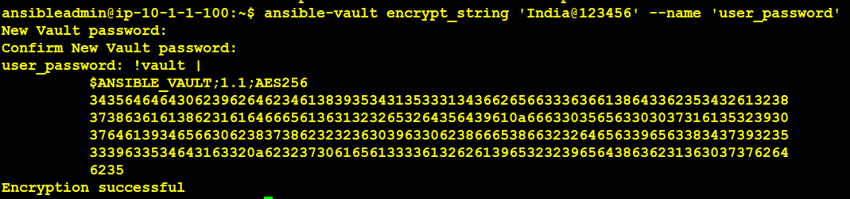

Decrypt the sting :

Make sure you delete the space before lines.

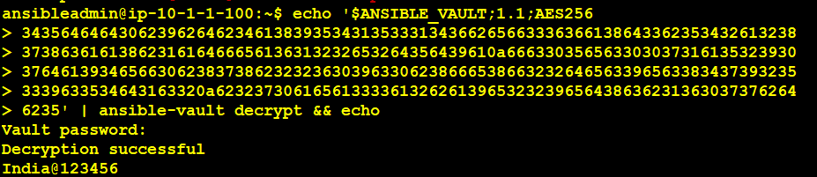

ansible-vault.yml

---

  - name: Ansible Vault Testing

    hosts: all

    become: yes

    become_user: root

    no_log: True

    vars:

     user_password: !vault | #to create a user we required provide the password

          $ANSIBLE_VAULT;1.1;AES256

          38616661636439666633373132333361653539646430363765326233323738666539373 4393737373439373338383434303461363138343431653534396165350a386136613834383

330623465663639383436666266393962636236386537386331623530613662623661636338313537303533666162343637353162623335660a3134613864363139393432313432643138363630633964323239353733643934

    tasks:

      - name: Create .aws folder

        shell: mkdir -p /root/.aws

        ignore_errors: yes

      - name: Replace Password Authentication To Yes #while deploy the machine by default in aws the password auth will be disable.

        ansible.builtin.lineinfile:

          path: /etc/ssh/sshd_config

          regexp: '^PasswordAuthentication no'

          line: PasswordAuthentication yes #we say in this line where the pass auth mention the ‘yes’

          backup: yes #the file get back

        notify:

        -  Restart SSH Service

      - name: Copy Encrypted File To /tmp

        copy:

          src: /home/ansibleadmin/terraform-ansible/aws_creds #This Encrypted File Must Be Created Prior To Running The Playbook.

          dest: /tmp/aws_creds

          owner: root

          group: root

          mode: '0600'

      - name: Copy Encrypted File To .aws folder

        copy:

          src: /home/ansibleadmin/terraform-ansible/aws_creds #This Encrypted File Must Be Created Prior To Running The Playbook.

          dest: /root/.aws/credentials

          owner: root

          group: root

          mode: '0600'

      - name: Creating adminuser

        user:

          name: anand

          state: present

          comment: Admin User Anand

          groups: root

          shell: /bin/bash

          group: root

          password: "{{ '%s' | format(user_password) | regex_replace('\n', '') | password_hash('sha512') }}"

          password_expire_min: 1

      - name: print the secure variable

        debug:

         var: user_password

      - name: Restart SSH Service

        shell: service sshd restart

    handlers:

      - name: Restart SSH Service

        shell: service sshd restart

